Kaylee Tincher

February 13, 2023

Experiment 3

**Introduction**

Our goal in this experiment was to determine the amount of sugar in a certain food. In this experiment we used sulfuric acid to convert the sugars to reducing sugars. We also used a copper reagent to oxidize the sugars we just reduced, and iodine was used to oxidize the copper II. Phenolphthalein was used as an indicator for titrations. The titrant used was sodium thiosulfate which was used to titrate the leftover iodine. The more titrant needed indicates the lower the amount of reducing sugars present in the sugar sample.

**Methods**

We created our Sugar Test Solution by adding 50mL of water and 5mL of .5 M sulfuric acid to .217 g corn syrup. It was then heated for 10 minutes in boiling water. After, it was cooled and 3 drops of phenolphthalein were added along with 3M NaOH until the solution stayed pink. Finally, the test solution was diluted with distilled water until the total volume equaled 50 mL.

After our Sugar Test Solution was created, 5mL of this solution was placed into two Erlenmeyer flasks Each flask received 5mL of copper reagent and were heated in boiling water for 15 minutes. During the heating process, the titration was set up with a 50mL biuret. It was rinsed with distilled water and filled up to the 0.0 mL mark with sodium thiosulfate.

After boiling, 5mL of .5M sulfuric acid was added to the flasks and then they were swirled around for around a minute. They were then titrated with the sodium thiosulfate until the dark yellow lightened. After the color lightened, the starch indicator solution was added. Finally, the flasks were titrated until a persistent light blue color appeared. Initial and final biuret readings were recorded.

**Report Sheet**

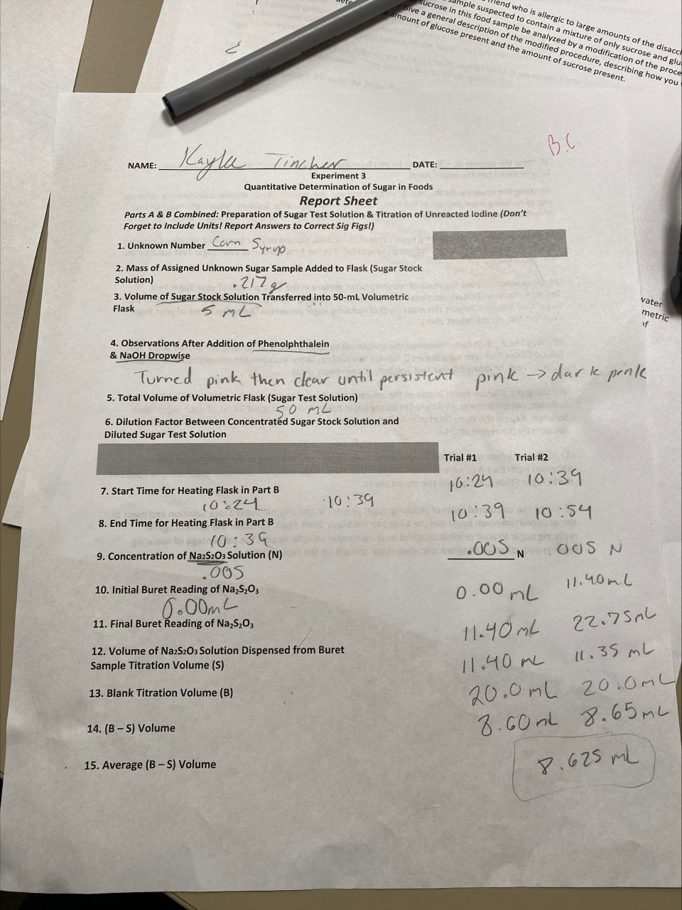

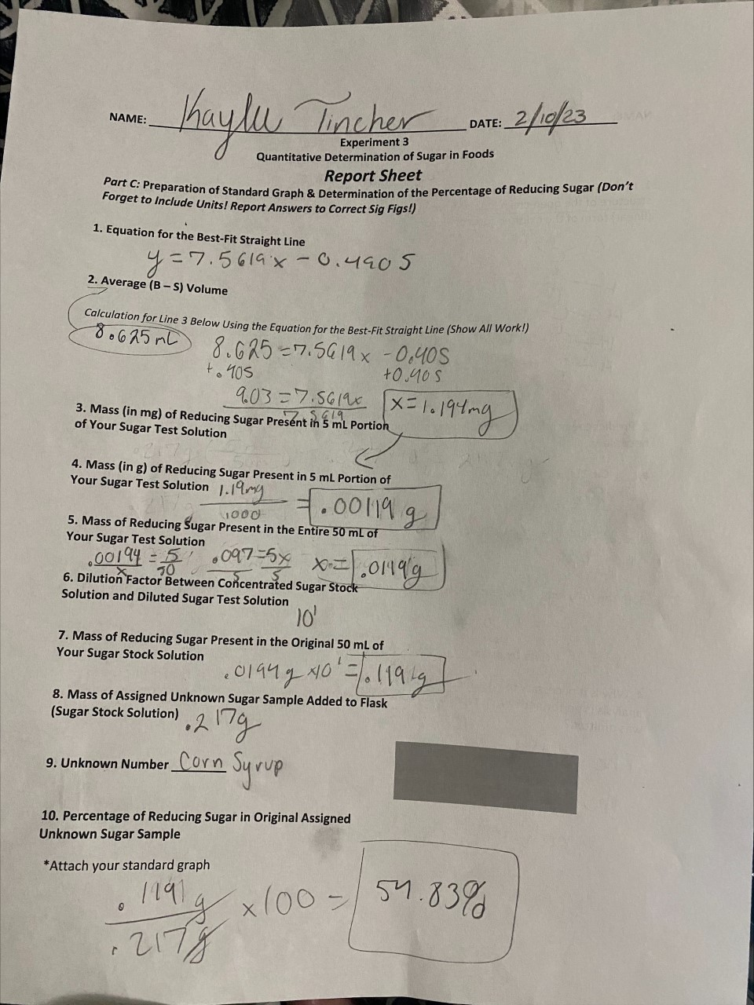

**Conclusions**

It took 11.4 mL of sodium thiosulfate to titrate the first sample trial and 11.35 mL to titrate the second sample trial. To titrate the blank solutions, it took 20 mL of sodium thiosulfate. The blank was not found by us during this experiment, instead, it was supplied by the instructor. After subtracting the sample volume from the blank and taking the average of the two trials, we were able to make a standard curve and plug in this average into the trendline equation. After calculating the mass of unknown sugar sample present in the original 50 mL of stock solution, it was divided by the original mass of our unknown sugar and multiplied by 100. This number gave us the percentage of reduced sugar in the original unknown sugar sample. Our calculations resulted in 54.83%.

**Questions**

1.

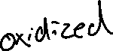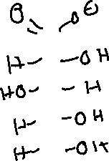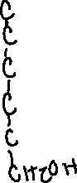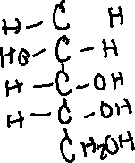

2.

a. ___Cu2O + H2SO4 🡪 ____Cu+ + ___CuSO4 + ____H2O

b. ___H2SO4 + _2_NaOH 🡪 ___NaSO4 + _2_ H2O

3. Gets Oxidized: IO3-, I - Gets Reduced: H+

4. The sulfuric acid and heat is needed to convert the sugar sample into reducing sugars so that they can be detected. Non-reducing sugars cannot be oxidized.

5. First, an iodine titration can be done to determine the amount of glucose in the food sample because iodine only reacts with reducing sugars. The iodine will not react with sucrose because it is a non-reducing sugar. After determining how much titrant was used, it can be determined how much reducing sugar was present. Next, sulfuric acid and heat can be used to hydrolyze the sucrose so that it breaks down into reducing sugars. Finally, another iodine titration can be used again to determine the amount of sugar broken down from the sucrose.

6. 2.50g x (10mL/125mL) = 0.2 g